SCS2208 Rapid Application Development

Lab Sheet - Basic JS

Part II

**Question 01**

Html Code

<!DOCTYPE html>

<html>

<head><link rel="stylesheet" href="styles.css"></head>

<body>

    <script type="text/javascript" src="index.js"></script>

<div>

  <form action="">

    <label for="name">Name:</label>

    <input type="text" id="name" name="name" placeholder="Insert a name..">

    <label for="hometown">Hometown:</label>

    <input type="text" id="hometown" name="hometown" placeholder="Insert home town..">

    <input type="submit" value="click" onclick="myFunction()">

  </form>

</div>

</body>

</html>

JavaScript Code (index.js)

*function* myFunction() {

    alert(`name is : ${document.getElementById("name").value}

hometown is : ${document.getElementById("hometown").value}`);

  }

CSS Code (styles.css)

input[type=text], select {

*width*: 100%;

*padding*: 12px 20px;

*margin*: 8px 0;

*display*: inline-block;

*border*: 1px solid #ccc;

*border-radius*: 4px;

*box-sizing*: border-box;

}

input[type=submit] {

*width*: 100%;

*background-color*: #4CAF50;

*color*: white;

*padding*: 14px 20px;

*margin*: 8px 0;

*border*: none;

*border-radius*: 4px;

*cursor*: pointer;

}

input[type=submit]:hover {

*background-color*: #45a049;

}

div {

*border-radius*: 5px;

*background-color*: #f2f2f2;

*padding*: 20px;

}

Output

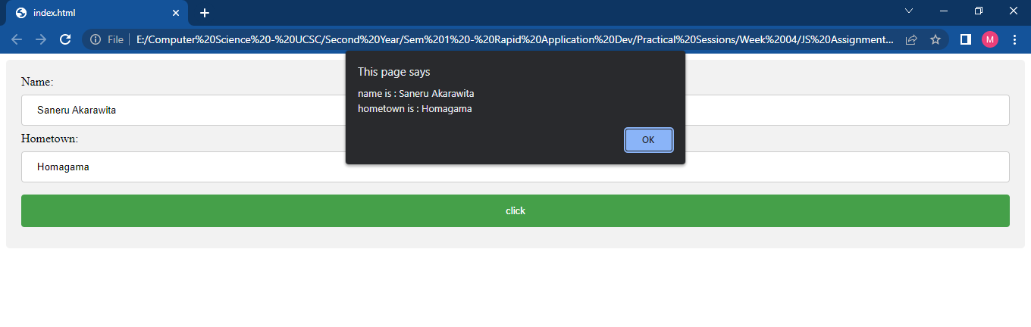

**Question 02**

Html Code

<!DOCTYPE html>

<html>

<head><link rel="stylesheet" href="styles.css"></head>

<body>

<div>

    <h4 id ="temp"></h4>

    <br><br>

    <input type="submit" id="buttemp" value ="">

</div>

<script type="text/javascript" src="index.js"></script>

</body>

</html>

JavaScript Code (index.js)

*var* current = new *Date*();

console.log(current.toLocaleTimeString())

document.getElementById("temp").innerHTML="Now the time is "+current.toLocaleTimeString();

*var* remhour = 24 - current.getHours()-1;

*var* remmin  = 60 - current.getMinutes();

console.log(remhour +":"+remmin)

document.getElementById("buttemp").value="Remains "+remhour +" hours and "+remmin +" more...";

CSS Code (styles.css)

input[type=text], select {

*width*: 100%;

*padding*: 12px 20px;

*margin*: 8px 0;

*display*: inline-block;

*border*: 1px solid #ccc;

*border-radius*: 4px;

*box-sizing*: border-box;

}

input[type=submit] {

*width*: 100%;

*background-color*: #4CAF50;

*color*: white;

*padding*: 14px 20px;

*margin*: 8px 0;

*border*: none;

*border-radius*: 4px;

*cursor*: pointer;

}

input[type=submit]:hover {

*background-color*: #45a049;

}

div {

*border-radius*: 5px;

*background-color*: #f2f2f2;

*padding*: 20px;

}

Output

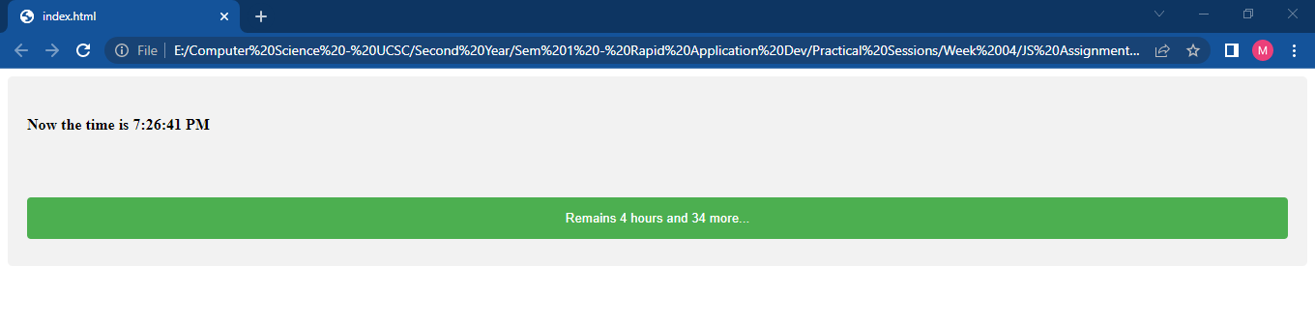

**Question 03**

Html Code

<!DOCTYPE html>

<html>

<head><link rel="stylesheet" href="styles.css"></head>

<body>

<div>

  <form action="">

    <label for="name">Name:</label>

    <input type="text" id="name" name="name" placeholder="Insert a name..">

    <label for="birthday">Birthday:</label>

    <br>

    <input type="date" id="bday" name="bday" placeholder="Insert Birthday.." value="">

    <input type="submit" value="click" onclick="bdayfunc()">

  </form>

</div>

<script type="text/javascript" src="index.js"></script>

</body>

</html>

JavaScript Code (index.js)

*function* bdayfunc() {

*var* dob = new *Date*(document.getElementById("bday").value);

  console.log(dob);

  //calculate month difference from current date in time

*var* month_diff = *Date*.now() - dob.getTime();

  //convert the calculated difference in date format

*var* age_dt = new *Date*(month_diff);

  //extract year from date

*var* year = age_dt.getUTCFullYear();

  //now calculate the age of the user

*var* age = Math.abs(year - 1970);

  //display the calculated age

  alert(`Age of the person: ${age} years`);

}

CSS Code (styles.css)

input[type=text],select {

*width*: 100%;

*padding*: 12px 20px;

*margin*: 8px 0;

*display*: inline-block;

*border*: 1px solid #ccc;

*border-radius*: 4px;

*box-sizing*: border-box;

}

input[type=date], select {

*width*: 100%;

*padding*: 12px 20px;

*margin*: 8px 0;

*display*: inline-block;

*border*: 1px solid #ccc;

*border-radius*: 4px;

*box-sizing*: border-box;

}

input[type=submit] {

*width*: 100%;

*background-color*: #4CAF50;

*color*: white;

*padding*: 14px 20px;

*margin*: 8px 0;

*border*: none;

*border-radius*: 4px;

*cursor*: pointer;

}

input[type=submit]:hover {

*background-color*: #45a049;

}

div {

*border-radius*: 5px;

*background-color*: #f2f2f2;

*padding*: 20px;

}

Output

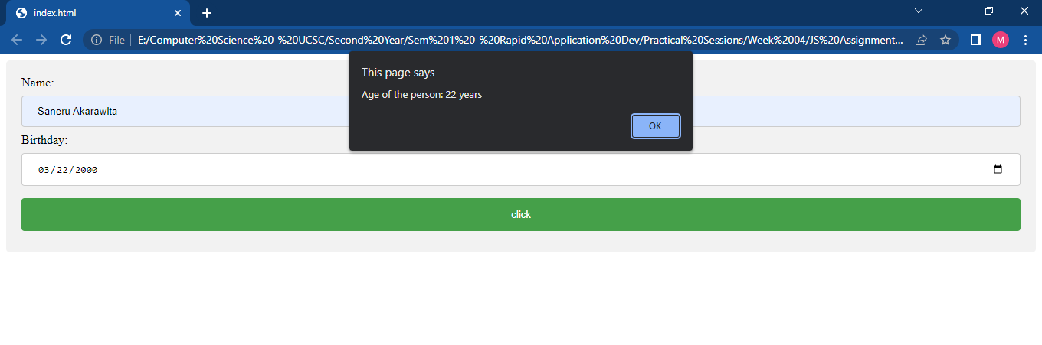

**Question 04**

Html Code

<!DOCTYPE html>

<html>

<head>

  <link rel="stylesheet" href="styles.css">

</head>

<body>

  <div>

    <form action="">

      <label for="name">Width:</label>

      <input type="text" id="width" name="width" placeholder="Insert width..">

      <label for="hometown">Height:</label>

      <input type="text" id="height" name="height" placeholder="Insert height..">

      <input type="button" value="Find Area" onclick="myFunction()">

    </form>

    <br><br>

    <p>

      <center>Area of the rectangle is <span id="areaval"></span> cm<sup>2</sup></center>

    </p>

  </div>

  <script type="text/javascript" src="index.js"></script>

</body>

</html>

JavaScript Code (index.js)

*function* myFunction() {

*var* width = document.getElementById("width").value;

*var* height = document.getElementById("height").value;

console.log(width);

console.log(height);

*var* area = width*height;

console.log(area);

document.getElementById("areaval").innerHTML=area;

 }

CSS Code (styles.css)

input[type=text],

select {

*width*: 100%;

*padding*: 12px 20px;

*margin*: 8px 0;

*display*: inline-block;

*border*: 1px solid #ccc;

*border-radius*: 4px;

*box-sizing*: border-box;

}

input[type=button] {

*width*: 100%;

*background-color*: #4CAF50;

*color*: white;

*padding*: 14px 20px;

*margin*: 8px 0;

*border*: none;

*border-radius*: 4px;

*cursor*: pointer;

}

input[type=button]:hover {

*background-color*: #45a049;

}

div {

*border-radius*: 5px;

*background-color*: #f2f2f2;

*padding*: 20px;

}

Output

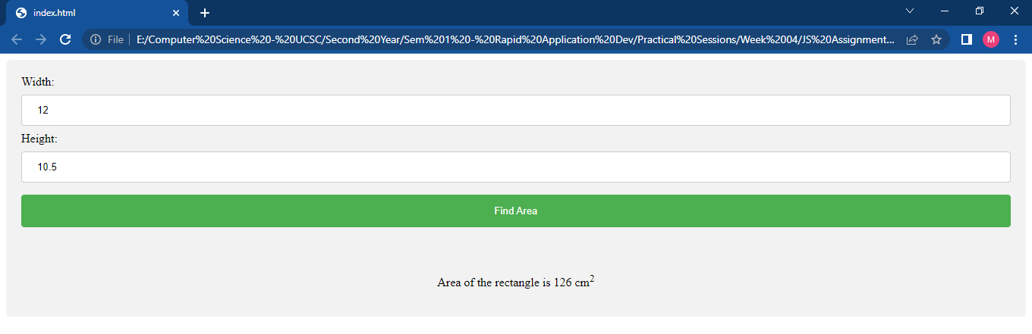

**Question 05**

Html Code

<!DOCTYPE html>

<html>

<head>

  <link rel="stylesheet" href="styles.css">

</head>

<body>

  <h2>Purchase Your Item</h2>

  <div>

    <p style="color:rgb(9, 146, 205);">Free Trial</p>

  </div>

  <p>&nbsp&nbsp Help you to Design</p>

  <p>&nbsp&nbsp Provide Security</p>

  <p>&nbsp&nbsp Manage your plans</p>

  <div>

    <input type="button" value="Try it Now" id ="btn" onclick="tempfunc()">

  </div>

  <script type="text/javascript" src="index.js"></script>

</body>

</html>

JavaScript Code (index.js)

*const* btn = document.getElementById('btn');

*function* onClick() {

    btn.style.backgroundColor = 'rgb(9, 146, 205)';

    btn.style.color = 'white';

}

*function* tempfunc(){

btn.addEventListener('click',onClick());

}

CSS Code (styles.css)

input[type=text],

select {

*width*: 100%;

*padding*: 12px 20px;

*margin*: 8px 0;

*display*: inline-block;

*border*: 1px solid #ccc;

*border-radius*: 4px;

*box-sizing*: border-box;

}

input[type=button] {

*width*: 10%;

*background-color*: #4CAF50;

*color*: white;

*padding*: 14px 20px;

*margin*: 8px 0;

*border*: none;

*border-radius*: 4px;

*cursor*: pointer;

}

input[type=button]:hover {

*background-color*: #45a049;

}

div {

*border-radius*: 5px;

*background-color*: #f2f2f2;

*padding*: 20px;

}

Output

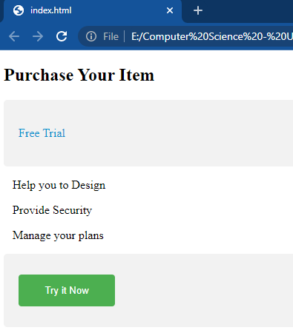 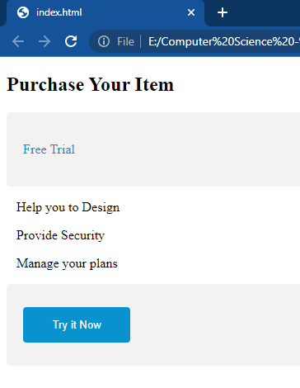

**Question 06**

Html Code

<!DOCTYPE html>

<html>

<head>

  <link rel="stylesheet" href="styles.css">

</head>

<body>

  <div>

    <p>Insert the Number:

      <input type="text" id="root" name="root" placeholder="Insert number..">

    </p>

    <input type="button" value="Find Root" id="btn" onclick="tempfunc()">

  </div>

  <script type="text/javascript" src="index.js"></script>

</body>

</html>

JavaScript Code (index.js)

*function* tempfunc() {

*var* num = document.getElementById("root").value;

    console.log(num);

*var* root = Math.sqrt(num);

    console.log(root);

    alert(`The Square root of ${num} is : ${root}`);

}

CSS Code (styles.css)

input[type=text],

select {

*width*: 100%;

*padding*: 12px 20px;

*margin*: 8px 0;

*display*: inline-block;

*border*: 1px solid #ccc;

*border-radius*: 4px;

*box-sizing*: border-box;

}

input[type=button] {

*width*: 10%;

*background-color*: #4CAF50;

*color*: white;

*padding*: 14px 20px;

*margin*: 8px 0;

*border*: none;

*border-radius*: 4px;

*cursor*: pointer;

}

input[type=button]:hover {

*background-color*: #45a049;

}

div {

*border-radius*: 5px;

*background-color*: #f2f2f2;

*padding*: 20px;

}

Output

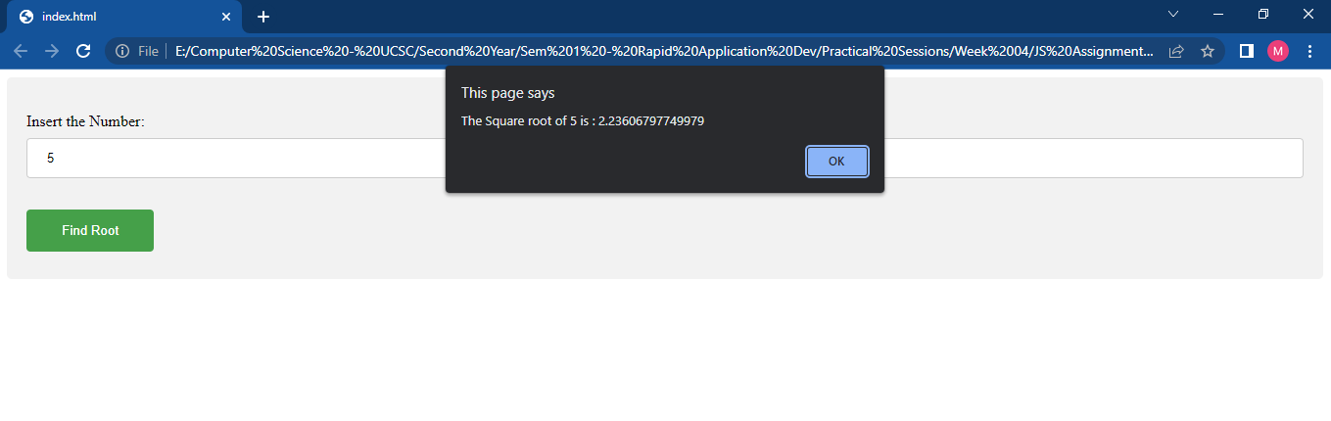

**Question 07**

Html Code

<!DOCTYPE html>

<html>

<head>

  <link rel="stylesheet" href="styles.css">

</head>

<body>

  <div>

    <h2>Available Hotel Packages</h2>

    <input type="checkbox" id="myCheck1" onclick="func1()">Wedding Package<br>

    <input type="checkbox" id="myCheck2" onclick="func2()"> Birthday Package <br>

    <input type="checkbox" id="myCheck3" onclick="func3()"> Normal Function Package <br>

    <input type="checkbox" id="myCheck4" onclick="func4()"> Dayout Package <br><br>

    <input type="button" value="Submit" id="btn">

  </div>

  <script type="text/javascript" src="index.js"></script>

</body>

</html>

JavaScript Code (index.js)

*function* func1() {

    document.getElementById("myCheck2").disabled = true;

    document.getElementById("myCheck3").disabled = true;

    document.getElementById("myCheck4").disabled = true;

}

*function* func2() {

    document.getElementById("myCheck1").disabled = true;

    document.getElementById("myCheck3").disabled = true;

    document.getElementById("myCheck4").disabled = true;

}

*function* func3() {

    document.getElementById("myCheck2").disabled = true;

    document.getElementById("myCheck1").disabled = true;

    document.getElementById("myCheck4").disabled = true;

}

*function* func4() {

    document.getElementById("myCheck2").disabled = true;

    document.getElementById("myCheck3").disabled = true;

    document.getElementById("myCheck1").disabled = true;

}

CSS Code (styles.css)

input[type=text],

select {

*width*: 100%;

*padding*: 12px 20px;

*margin*: 8px 0;

*display*: inline-block;

*border*: 1px solid #ccc;

*border-radius*: 4px;

*box-sizing*: border-box;

}

input[type=button] {

*width*: 10%;

*background-color*: #4CAF50;

*color*: white;

*padding*: 14px 20px;

*margin*: 8px 0;

*border*: none;

*border-radius*: 4px;

*cursor*: pointer;

}

input[type=button]:hover {

*background-color*: #45a049;

}

div {

*border-radius*: 5px;

*background-color*: #f2f2f2;

*padding*: 20px;

}

Output

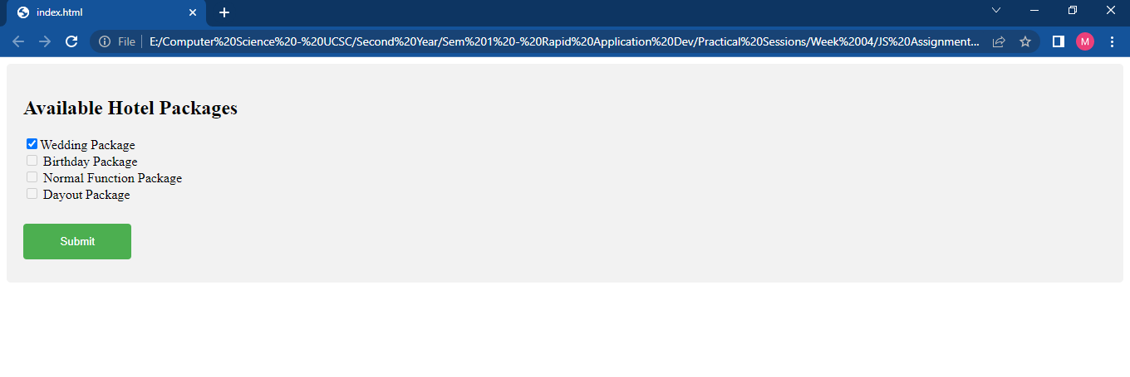

**Question 08**

Html Code

<!DOCTYPE html>

<html>

<head>

  <link rel="stylesheet" href="styles.css">

</head>

<body>

  <div>

    <form action="">

      <label for="number">Insert the amount:</label>

      <input type="text" id="number" name="number" onmouseout="myFunction()">

      <br><br>

      <p>

        20% of the value: <span id="pvalue"></span>

      </p>

      <p>

        Total: <span id="ovalue"></span> + <span id="pvalue2"></span> = <span id="totvalue"></span>

      </p>

    </form>

  </div>

  <script type="text/javascript" src="index.js"></script>

</body>

</html>

JavaScript Code (index.js)

*function* myFunction() {

*var* number = parseInt(document.getElementById("number").value);

console.log(number);

*var* percentage = number*20/100;

console.log(percentage);

*var* tot = number+percentage;

console.log(tot);

document.getElementById("ovalue").innerHTML=number;

document.getElementById("pvalue").innerHTML=percentage;

document.getElementById("pvalue2").innerHTML=percentage;

document.getElementById("totvalue").innerHTML=tot;

 }

CSS Code (styles.css)

input[type=text],

select {

*width*: 100%;

*padding*: 12px 20px;

*margin*: 8px 0;

*display*: inline-block;

*border*: 1px solid #ccc;

*border-radius*: 4px;

*box-sizing*: border-box;

}

input[type=button] {

*width*: 100%;

*background-color*: #4CAF50;

*color*: white;

*padding*: 14px 20px;

*margin*: 8px 0;

*border*: none;

*border-radius*: 4px;

*cursor*: pointer;

}

input[type=button]:hover {

*background-color*: #45a049;

}

div {

*border-radius*: 5px;

*background-color*: #f2f2f2;

*padding*: 20px;

*border-width*: 5px;

*border-style*: double;

*border-color*: black;

}

Output

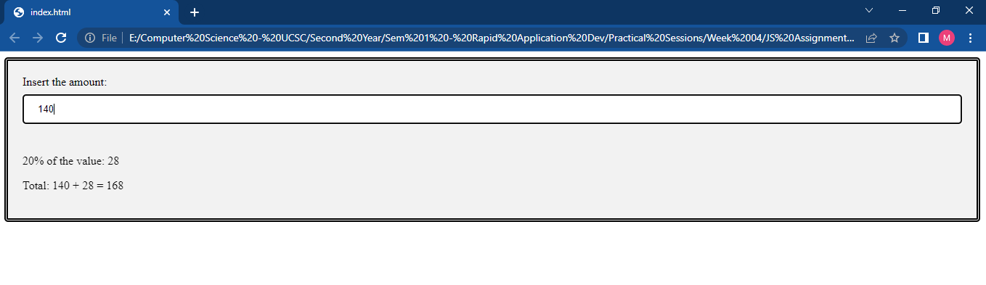

**Question 09**

Html Code

<!DOCTYPE html>

<html>

<head>

  <link rel="stylesheet" href="styles.css">

</head>

<body>

  <div>

    <form action="">

      <label for="subject">Subject:</label>

      <input type="text" id="subject" name="subject" placeholder="Please enter the subject...">

      <label for="mark">Marks:</label>

      <input type="text" id="mark" name="mark" placeholder="Enter marks...">

      <input type="button" value="Results" onclick="myFunction()">

    </form>

    <p><span id="msg"></span></p>

  </div>

  <script type="text/javascript" src="index.js"></script>

</body>

</html>

JavaScript Code (index.js)

*function* myFunction() {

*var* subject = document.getElementById("subject").value;

  console.log(subject);

*var* marks = document.getElementById("mark").value;

  console.log(marks);

  if (subject != '' && marks != '') {

    if (marks <= 35) {

      document.getElementById("msg").innerHTML = "Sorry... You have to work hard for " + subject + " subject";

    }

    else {

      document.getElementById("msg").innerHTML = "Congratsss...! You have passed the " + subject + " subject";

    }

  }

}

CSS Code (styles.css)

input[type=text], select {

*width*: 100%;

*padding*: 12px 20px;

*margin*: 8px 0;

*display*: inline-block;

*border*: 1px solid #ccc;

*border-radius*: 4px;

*box-sizing*: border-box;

}

input[type=button] {

*width*: 100%;

*background-color*: #a9339d;

*color*: white;

*padding*: 14px 20px;

*margin*: 8px 0;

*border*: none;

*border-radius*: 4px;

*cursor*: pointer;

}

input[type=button]:hover {

*background-color*: #a9339d;

}

div {

*border-radius*: 5px;

*background-color*: #f2f2f2;

*padding*: 20px;

}

Output

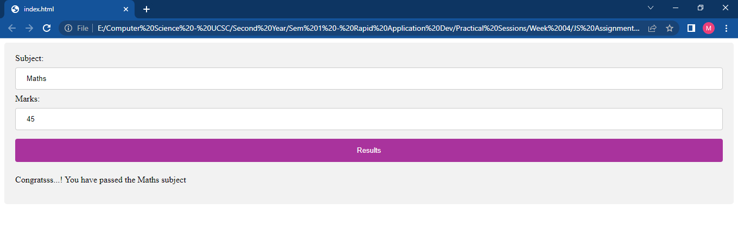

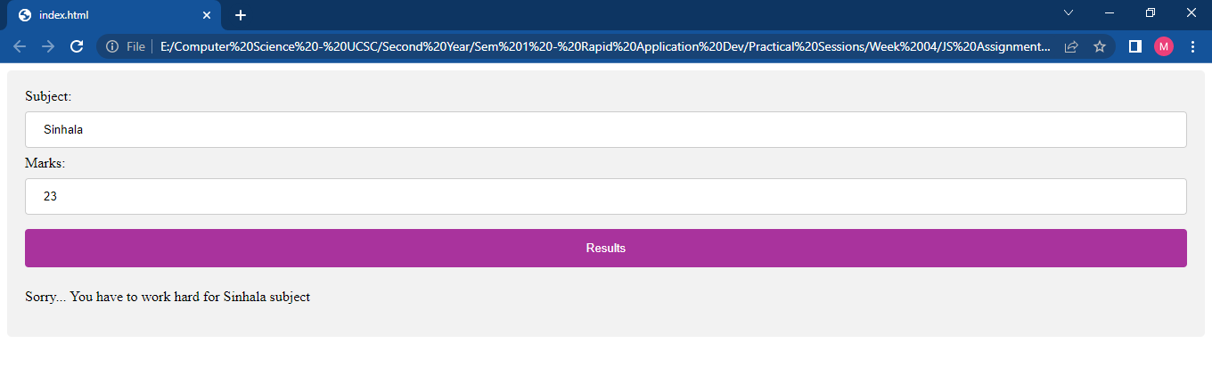

**Question 10**

Html Code

<!DOCTYPE html>

<html lang="en">

<head>

    <meta charset="UTF-8">

    <meta http-equiv="X-UA-Compatible" content="IE=edge">

    <meta name="viewport" content="width=device-width, initial-scale=1.0">

    <script src="index.js" type="text/javascript"></script>

    <link rel="stylesheet" href="styles.css">

    <title>Document</title>

</head>

<body>

    <h1 style="text-align:center">Mini Calculator</h1>

    <div class="container">

        <br>

        <table>

            <tr>

                <td colspan="3"><input type='text' id='result' class='screen' style="text-align: right;"></td>

                <td>

                    <input type='button' value='C' onclick="clearScreen()" class="clear" />

                </td>

            </tr>

        </table>

        <div class="keys">

            <input type="button" value="7" class="button" onClick="display('7')"></input>

            <input type="button" value="8" class="button " onClick="display('8')"></input>

            <input type="button" value="9" class="button" onClick="display('9')"></input>

            <input type="button" value="/" class="operator" onClick="display('/')"></input>

            <input type="button" value="4" class="button" onClick="display('4')"></input>

            <input type="button" value="5" class="button" onClick="display('5')"></input>

            <input type="button" value="6" class="button" onClick="display('6')"></input>

            <input type="button" value="*" class="operator" onClick="display('*')"></input>

            <input type="button" value="1" class="button" onClick="display('1')"></input>

            <input type="button" value="2" class="button" onClick="display('2')"></input>

            <input type="button" value="3" class="button" onClick="display('3')"></input>

            <input type="button" value="-" class="operator" onClick="display('-')"></input>

            <input type="button" value="0" class="button" onClick="display('0')"></input>

            <input type="button" value="." class="button" onClick="display('.')"></input>

            <input type="button" value="=" class="button equal-sign" onClick="solve()"></input>

            <input type="button" value="+" class="operator" onClick="display('+')"></input>

        </div>

    </div>

</body>

JavaScript Code (index.js)

*function* display(*val*) {

    document.getElementById('result').value += *val*

    return *val*

}

*function* solve() {

*let* x = document.getElementById('result').value

*let* y = eval(x);

    document.getElementById('result').value = y

    return y

}

clearScreen()

*function* clearScreen() {

    document.getElementById('result').value = ''

}

CSS Code (styles.css)

.container {

*border*: 1px solid #cccccc;

*box-shadow*: 10px 10px 30px 0px rgba(0,0,0,0.75);

*border-radius*: 20px;

*position*: absolute;

*top*: 55%;

*left*: 50%;

*transform*: translate(-50%, -50%);

*width*: 450px;

*height*: 400px;

}

.keys {

*display*: grid;

*grid-template-columns*: repeat(4, 1fr);

*grid-gap*: 10px;

*padding*: 10px;

*margin*:auto;

}

.button {

*height*: 60px;

*padding*: 5px;

*background-color*: #fff;

*border-radius*: 3px;

*border*: 1px solid #c4c4c4;

*background-color*: transparent;

*font-size*: 2rem;

*color*: #333;

*background-image*: linear-gradient(to bottom, transparent, transparent 50%, rgba(0,0,0,.04));

*box-shadow*: inset 0 0 0 1px rgba(255,255,255,.05), inset 0 1px 0 0 rgba(255,255,255,.45), inset 0 -1px 0 0 rgba(255,255,255,.15), 0 1px 0 0 rgba(255,255,255,.15);

*text-shadow*: 0 1px rgba(255,255,255,.4);

}

.button:hover {

*background-color*: #eaeaea;

}

.operator {

*color*: #fff;

*background-color*: #eebb24;

}

.clear {

*background-color*: #f0595f;

*border-color*: #b0353a;

*color*: #fff;

*width*: 80px;

*height*: 30px;

*margin-left*: 15%;

}

.clear:hover {

*background-color*: #f17377;

}

.equal-sign {

*background-color*: #25a8e0;

*border-color*: #25a8e0;

*color*: #fff;

}

.equal-sign:hover {

*background-color*: #4e9ed4;

}

.screen{

*background-color*:rgb(171, 219, 231);

*justify-content*: left;

*color*: black;

*font-size*: medium;

*width*: 50%;

*height*: 30%;

*cursor*: default;

*padding*: 10px;

*padding-left*: 40%;

*margin*: auto;

*margin-bottom*: 10px;

*margin-left*: 15px;

}

Output

